Make an interactive map for your school!

Name: Class: Due Date:

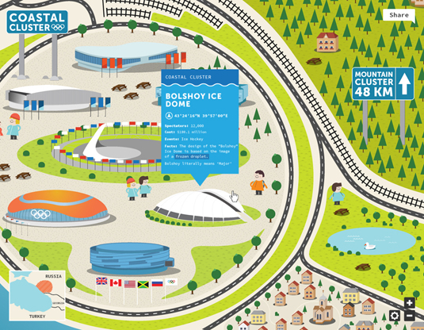

We have many parents, members of the community and new students who come to our school, sometimes they can get lost and find it difficult to find their way around the school grounds.

Your job is to create an interactive map that can be used on an I-pad to assist new students and guests to find their way around our school.

Why?

Using a source of technology such as an I-pad or an I-phone helps reduce the amount of paper the office is using when they hand out maps. This helps us improve the sustainability of our future.

Below are the steps you need to follow in order to complete the task. You will also be provided with a range of activities and tasks in class to complete this assessment. Make sure you complete ALL of these. Use the steps below as a checklist, make sure that you have ticked all of them before you submit.

Before you start work through the rubric with your teacher. Continue to check this as you work through your assessment task. Good Luck!

What you need to do?

- Make a map of the school using the grid map provided by your teacher – you can draw this, use photos, or create on the computer.
- Choose 4 directions of your choice- write/record the routes you have taken using directional language (using pixie) on how to get to the areas of your choice

You can choose from the following:
- From the office to the year 5/6 unit block
- From the office to the year 3/4 unit block
- From the unit block of your choice to the tuckshop
- From the unit block of your choice to the oval
- From the unit block of your choice to the library
- From the unit block of your choice to the playground
- From the unit block of your choice to the school hall

- Change these directions into sequences (using arrows) and the grid paper to get to the four areas of your choice

Office
Hall
Directions from office to the school hall: (example)

- Give your map to a partner to trial. Did the directions you provided reach the location? Was it easy for them to follow?

- Create your school map on Scratch- input the sequences for the 4 different routes you chose.

- Record your voice, using directional language for each of the routes you have created

- Save your Scratch on the classrooms account for marking by your teacher. Be sure that you have completed all of these steps and steps provided in class AND check your work against the criteria sheet.

